Implementating Cross-Enterprise Document Sharing (XDS.b) based on Blockchain Technology

Petnathean Julled   
line 2: *dept. name of organization   
(of Affiliation)*  
line 3: *name of organization   
(of Affiliation)*line 4: City, Country  
line 5: email address or ORCID

Assadarat Khurat  
line 2: *dept. name of organization   
(of Affiliation)*  
line 3: *name of organization   
(of Affiliation)*line 4: City, Country  
line 5: email address or ORCID

Pattanasak Mongkolwat  
line 2: *dept. name of organization   
(of Affiliation)*  
line 3: *name of organization   
(of Affiliation)*line 4: City, Country  
line 5: email address or ORCID

*Healthcare information sharing and interoperability between healthcare organizations are important factors to healthcare quality and safety since a patient may require medical services and consultations from different healthcare provides. Many challenges inhibit successful data sharing such as data integrity, security and privacy. Integrating Healthcare Enterprise (IHE) provides Cross-Enterprise Document Sharing (XDS.b) profile that allows the adopted organizations to share health documents between institutions. No specific security implementations were endorsed, which allows latest security technologies to be applied.. Healthcare domain has become a major target in emerging cyber-security threats. These threats increase difficulty to maintain secure health information sharing network. These cyberthreats can compromise integrity and availability of data and effect patient’s life. Blockchain technology can be used to solve health information sharing issues. A novel method using Blockchain technology to ensure health information integrity and availability is implemented, demonstrated and freely available(?), allowing health document sharing through decentralized network while addressing cyber-security issues through unique characteristics of Blockchain technology.*



Keywords—health information, interoperability, information sharing, information security, blockchain, smart contract, ihe, xds

# Introduction

The is increasing demand for better quality of healthcare services, operation efficiency pays important roles in patient services and economic outcomes. Healthcare information sharing and interoperability between healthcare organizations are one of major solutions to improve healthcare service quality. Patient’s health documents are scattered across different healthcare organizations, which may cause by different medical services being offered from different providers. Each healthcare provider has their own methods, processes, and workflow to handle healthcare information. This makes it harder for one health information system to interoperate with one another. Sharing health information with trusted party who may not employ highest level of security standards and practices exposing vulnerabilities to patients, business, and organization. The risk-reward ratio from sharing patients’ information with other may not be worthwhile if it were done improperly. This create high friction for one organization to share their information with others. It even more difficult for individual patient to integrate and share their health information between different providers. It revealed that these interoperation problems cause huge decrease in efficiency on healthcare operation and result as lower quality of healthcare service [1–8]. Therefore, there are many initiatives [9–11] that start to standardize healthcare information technology with the goal to allow healthcare organizations to be able to exchange patients’ information with each other. By applying Blockchain technology on the Cross-Enterprise Document Sharing (XDS.b) Profile created by Integrating Healthcare Enterprise (IHE) initiative, Blockchain increases ? What do you want to say here?.

Besides the issue regarding health information sharing between different enterprises, there are also emerging cyber-security threats that threatening healthcare domain. There are many incidents report that Hospitals have been hit by ransomware that gave medical operation severe disruptions in recent years [12–14]. The number of patient records breached has been on an increase every year from 2012 to2014. Security experts estimated the number of ransomware attacks on healthcare institute to be close to 1,000 per day in 2015, which is 35% more than the previous year. The number even rose to 4,000 attacks on certain days according to a report published by Symantec in 2016. Many cases show that failing on secure integrity and availability of healthcare information cause a major disruptive factor on continuity of medical operation. Assumed that organization policy and employee security awareness about cyber-security were addressed, there are several techniques proposed to mitigate the problem. One of major solution being propose is utilization of Blockchain technology on healthcare information or its infrastructure. Cryptographical components and consensus mechanism of Blockchain will give immutable characteristic and secure integrity of the information, while decentralization of published data help secures its availability [16]–[19].

Blockchain can be informally defined as a distributed digital ledger of cryptographically signed transactions that are grouped into blocks. [20] Each block is cryptographically linked to the previous one (making it tamper evident) after validation and undergoing a consensus decision. As new blocks are added, older blocks become more difficult to modify (creating tamper resistance). New blocks are replicated across copies of the ledgers within the network, and any conflicts are resolved automatically using established rules. This give its characteristics to sustain threat against integrity and availability of information. At the same time, with consensus as vital part of Blockchain, it allows members of Blockchain network to systematically “trusted” each other without the need of mutuality trust or physical agreement. Additionally, as distributed decentralized network, Blockchain requires each member to passively share information with each other. Since the introduction of the first Blockchain based cryptocurrency named ‘Bitcoin’, there are many Blockchain platforms and service providers entered the industry. One of major platform adopt by many kinds of applications is Ethereum. Ethereum was the first major platform that introduce usage of Blockchain in the field of application other than cryptocurrency with its ‘Smartcontract’. Smartcontract allows developers to publish logic models or computational algorithms into Blockchain which enables a while variety of usage for the technology [21], [22].

As for addressing issues regarding health information sharing between different enterprises, there are concepts of utilizing Blockchain proposed by Mayo Clinic and “MedRec” MIT. Both introduce an effective way with potential to utilize Blockchain technology for information sharing in healthcare enterprise environment. The work given great demonstration of how decentralization offered by Blockchain can resolve trust issue where each enterprise require “trust” before beginning to share their information with others. However, both solutions are not yet directly introduced how Blockchain can help mitigate cyber-security threats threatening integrity and availability of data in healthcare domain. In this work, we propose a solution that can solve data integrity and availability issues while help reduce the friction of allowing health document sharing between different enterprises by utilizing Ethereum’s Smartcontract to enable implementation of IHE XDS.b Profile concept with Blockchain.

This paper provides sufficient information in six main sections. It begins with the related works that inspire our design in section II, following with background knowledge which our work is based on in section III. Then, we move into the detail of design method in section IV before dive into implementation technic for?demonstration in section V. At last, we wrap up the concept propose in this work for conclusion in section VI and end with discussion for this work in section VII.

# RELATED WORK

## A Blockchain-Based Approach to Health Information Exchange Networks [23]

Kevin Peterson et al. from Mayo Clinic have proposed the concept that using Blockchain as a medium for health information exchange network. The work utilizes Fast Healthcare Interoperability Resources (FHIR) protocol as a gateway which allows members of the network to access health information from each other, while ensure distribution of accessibility within the network by published those gateways to Blockchain. Every activity on the network will be recorded on the Blockchain providing audit trail for the network. They proposed several concept ideas about using computational resource within Blockchain network in the more meaningful way contribute to healthcare environment. Additionally, the work also included several suggestions about Blockchain component that may provide more compatibility of the technology for healthcare information environment. In this work, we adopt the idea of using Blockchain as a medium for health information exchange network and several suggestions provided, that should make Blockchain technology more compatible with healthcare information environment. However, the work did not mention about how Blockchain technology can be beneficial for health information sharing in term of cyber-security.

## “MedRec” prototype for electronic health records and medical research data

MedRec [24] was proposed as a prototype for electronic health records by utilize Ethereum’s smartcontract to contain metadata about the record ownership, permissions and data integrity represent existing medical records that are stored within individual nodes on the network. The concept helps reduce barriers to effective data sharing addressing interoperability issue caused by economic incentives that encourage “health information blocking”. At the same time, their proposal also benefits as the source of medical research data, by providing anonymized healthcare data for research institutions in the form of Blockchain participation reward. Their Blockchain implementation focus on addressing four major issues for health information exchange included: fragmented data which also slow access to medical data, system interoperability, patient agency, and improved data quality and quantity for medical research. Additionally, as MedRec was built on the work of Zyskind et al .[25], they also utilize some cryptographical characteristics of Blockchain to provide accessible “bread crumb trail” which allows data user to trace back medical history to improve operation efficiency. From MedRec, we adopt the concept of using Ethereum’s smartcontract to contain essential information that allow ability to discover data within Blockchain network. However, the concept may require overhaul and rework on the whole system for adoption which may not be affordable in some cases, like the organization may have limited resources or recently invested most of their available resources on making their system comply with existing health information sharing standard.

# BACKGROUND KNOWLEDGE

## Cross-Enterprise Document Sharing (XDS.b) Profile from Integrating Healthcare Enterprise initiative (IHE)

Modern medical operation has large amount of healthcare information flow within the system. Throughout the age, many medical service providers and organizations have developed their own health information system and database to increase efficiency of operation in their medical services. As the time past, information of individual patients has scattered amongst different systems. This becomes a new challenge for healthcare enterprise to further enhance their medical service efficiency by sharing health information with other systems within healthcare industry domain

IHE is an initiative by healthcare professionals and industry to improve the way health information systems in healthcare integrate and share information. IHE promotes the coordinated use of established standards such as HL7 and DICOM [11] to address specific clinical needs in support of optimal patient care. Systems developed in accordance with IHE integrate and communicate with one another better, are easier to implement, and enable healthcare providers to use information more effectively. This helps enable seamless and secure access to health information that is usable whenever and wherever needed. An IHE profile provides use of existing standards, specifications, tools, and services for interoperability. IHE also engages clinicians, health authorities, industries, and users to develop, test, and implement standards-based solutions to vital health information needs. [26] IHE provides convenient and reliable way of specifying a level of compliance to standards enough to successfully reach efficient interoperability.

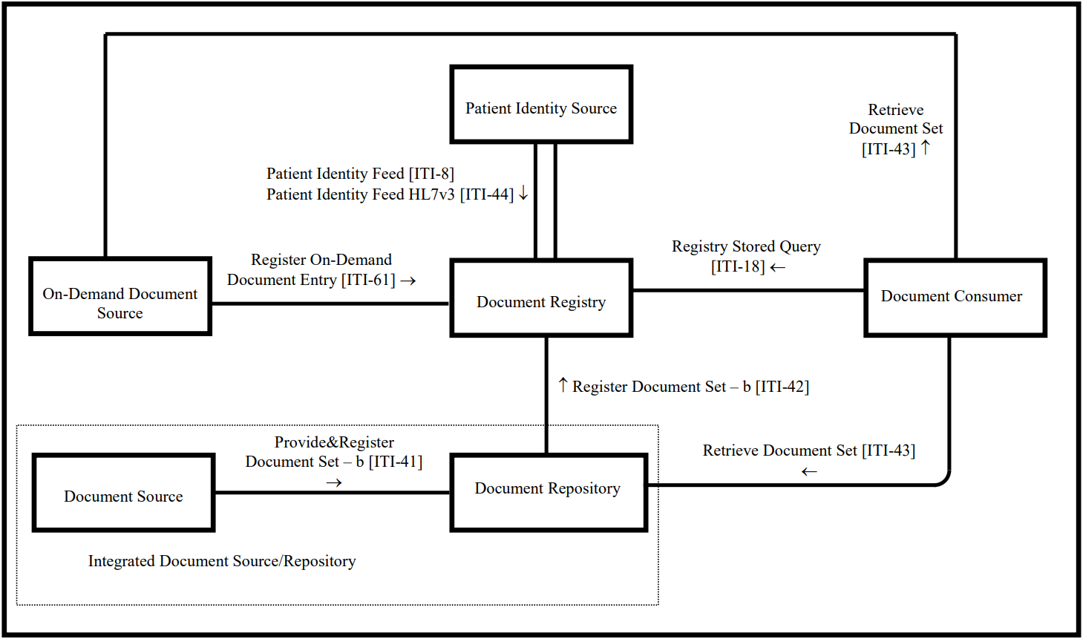

Figure 1 Cross-Enterprise Document Sharing – Set b [27]

Amongst many profiles created by IHE, there is one major profile that serve to improve efficiency of health information sharing between different enterprises called “Cross-Enterprise Document Sharing Profile (XDS.b)” [27] (Figure 1. Not should if you need to show this?). The main goal of XDS.b profile is to allow enterprises that being a member of health document sharing network (called “XDS Affinity Domain”) to discover shared health documents stored in the system of other institutions via central registry (named “XDS Document Registry”). The XDS Document Registry registers set of META-data attributes belong to each health documents to allow health information system to discover existing health document that stored within other organizations and able to systematically access the document using the information provided by META-data attributes. By specified format of transactions and method for each system to communicate with each other, XDS.b makes sure that all the systems within the network can communicate with each other in the same way. This allows document consumer and user in the network to share health documents with each other and put it to use as needed efficiently.

In Figure 1, each XDS “Actor” represents machine or software which takes the role in XDS.b Profile. Health document and its META-data attributes initially generated from Document Source Actor such as X-ray machine, physicians’ EMR terminal, etc. The generated documents and their META then store in Document Repository Actor via Provide & Register Document Set-b [ITI-41] transaction. The actor mostly referred to database or server which keep health documents available and ready for usage in healthcare operation. After that, Document Repository Actor register META-data attributes of stored document to Document Registry Actor via Register Document Set-b [ITI-42] transaction. The META-data attributes will contain information essential for Document Consumer Actor to discover health document available within XDS Affinity Domain and enable interoperability between corresponding software. Document Consumer Actor queries for information of registered document in Document Registry Actor via Registry Stored Query [ITI-18] transaction. Document Registry then returns query result to Document Consumer Actor via transaction following ITI-18 format. Eventually, Document Consumer Actor use information provided by query result to retrieve the document from its repository using Retrieve Document Set [ITI-43] transaction. It is expected that Document Repository Actor response to the request by sending copy of the document back to the Document Consumer Actor. For On-Demand Document Source, it is equivalent to Document Repository Actor as both are where Document Consumer retrieve those documents they seek. The only different is that On-Demand Document Source acts as repository which will immediately generate a health document at the time of request as the document only represents its subject at the time, while document stored within Document Repository represents event in health operation that already ended. For Patient Identity Source Actor, the actor acts as assistant for XDS Affinity Domain to identify identity of the same patient within the domain whose can be represent differently in each enterprise. This actor may not be necessary if XDS Affinity Domain already have policy or agreement which regulates all enterprises in the domain must use the same identification to identify the same patient. With these XDS Actor and transaction deployed, it ensures that all enterprise within XDS Affinity Domain can achieve and share health documents with each other.

## Blockchain Technology

Blockchain technology is a method that applied cryptographic techniques to locally ensure integrity of data while rely on decentralization and consensus mechanism to ensure integrity and availability of all data existing in the network [20]. These cryptographical techniques include the one that form “Block” and another one that form “Chain”. In Blockchain, those data being published are small fragment of information that represent proof of action in its own application. Therefore, it calls a “transaction”. A set of transactions approach Blockchain network at the same period will be hashed together, imagine like put these transactions into the same box and label it with its hash value, formed a “Block”. Additionally, the hash value of each block also includes hash value of previously generated block cause formation of a “Chain”. Any attempt to modify content of published block will cause change in hash value of entire chain which trigger rejection from the network.   
Together with hash “chain”, the concept also relies on “decentralization” of data where copy of entire chain was kept by many participants of the network called “node”. Any node with the version of chain that has even a bit different from the majority in the network will be rejected and the node will be forced to adopt the version adopted by the majority. These two techniques form together to become “Blockchain” which prevents modification of published content and ensure integrity of data. This concept guarantee that no one can ever be able to modify any data existing in Blockchain. However, there still be able to add more Block into Chain by utilization of consensus mechanism [28].

Consensus mechanism invented to ensure that no one in the network can freely attempt to modify content of transaction before it being published inside Blockchain, whether by select a trustable node who will verify certain Block being publish to the chain or have majority of reliable node approve authenticity of newly formed Block [29]. Some consensuses like Proof of Work (PoW), require participant nodes (called “miner”) who wants to verify a Block to compete to solve mathematic puzzle. The winner will be able to verify the Block and get reward based on each network policy. As the puzzle requires each node to spend huge amount of computational resource, given randomness which make it nearly impossible for miner node to be able to get a hand on prefer Block and attempt suspicious activity during verification process [30]. On the other hand, some consensus mechanisms like Practical-Byzantine False Tolerance (PBFT), invented to allow Blockchain network with limited computational resource to select trustable validator. This kind of consensus use voting mechanism which sacrifice ability to welcome anonymous node for lesser computational resources required for maintaining Blockchain and increased in efficiency of verification process, that means it rely on the environment that most of the nodes are not corrupted [31]. These mechanisms enable transparency in publication and verification of transaction in Blockchain. Additionally, the network also needs compatible permission model for its member to maximize effectiveness of consensus mechanism. According to [20], Blockchain can be categorized into two main types based on its permission model which determines who can maintain blockchain ledger (i.e. publish block). Permissionless blockchain networks provide simplicity in scalability of the network by allowing anyone in the network to maintain blockchain ledger. At the same time, permissioned chain allows only selected member to maintain or even just to participate in the network which allows accountability and auditability of the network in exchange for simplicity in scalability. Permissioned blockchain networks may also be used by organizations that wish to work together but may not fully trust one another. They can establish a permissioned blockchain network and invite business partners to record their transactions on a shared distributed ledger. The transparency provides by Blockchain and consensus with suitable permission model then create a passive “trust” amongst the network as no one in the network have absolute right to rules and manipulate the network and its content at their own will [32].

## Ethereum and smartcontract

Ethereum is one of well-known open source Blockchain platform. The platform initially invented by a developer named Vitalik Buterin and further developed by Ethereum community. Main approach of Ethereum Blockchain is about using Blockchain technology for applications other than cryptocurrency. The platform proposed concept about “smart contract” [21,22]. Smartcontract allows developers to integrate their small size of computation algorithms or snippet of logic into Blockchain. This gives Blockchain characteristics [17] to those code. Enable wide variety of applications to work with Blockchain. The concept of smartcontract later was adopted by other Blockchain platform, created infinite possibilities of Blockchain application suitable with variety of computational environment and usage. While each Blockchain platforms have their own technical methods for implementation, Ethereum’s smartcontract relies on Javascript-like language called ‘Solidity’. The language invented to allow codification of human-understandable logic into programming language format understandable by ‘Ethereum Virtual Machine (EVM)’ named ‘JSON-RPC’. EVM represents a computational resource that shares amongst Ethereum network which allows machines with different environments to interact with Ethereum Blockchain without the need for specific computational environment or hardware. This allows Ethereum network to formed by wide variety of machines with different operation system and internal environment. At the same time, Ethereum Blockchain can adopt variety of consensus mechanism. The main Ethereum Blockchain initially adopted PoW. Due to limitation as it requires huge amount of computational resource to stay active, Ethereum network later forked the Blockchain line into several chain lines with different consensus. i.e. Proof of Stake and PBFT which adopt voting-like mechanism to allow reduction of computational resources consumption. As time passed, Ethereum community keeps on growing, now there are wide variety of consensus mechanism proposed to suit with different application and network environment.

# METHOD

This section describes a method of how we implement XDS.b Profile based on Blockchain technology. Start with a general use case scenario following with top view of the Blockchain network and consecutively narrowing into the design of XDS Blockchain, its components, and Smartcontract which took the main role to adapt the profile into the chain.

## A Use Case Scenario

As shown in Figure 2, user at Hospital (A) needs to start with specifying value corresponding to XDS META-data attributes (Patient name, ID, etc.) that unique to the event specific for Mr.Bob and use it to search for associated registry using Document Registry Searcher program. Document Registry Searcher uses specified values to find for registered META-data attributes set in smartcontract. When matched, Document Registry Searcher returns the whole META-data attributes set of those matched one to the user at Hospital (A). In this case, it may return more than one registry set that associated with Mr.Bob. User at Hospital (A) may need to seek for the one with latest timestamp or the one they needed to use. When the registry set was picked, they may need to use repository URI included in META-data attributes set to request for actual document in Hospital (B). After that, Hospital (B) will response by allow Hospital (A) to access content of the document.

Due to unique nature of healthcare environment that emphasizes on confidentiality of data, this cause limit in implementation of the technology in the environment. Patient data cannot be put directly into Blockchain as it will become persistent by decentralization of Blockchain network as well as it will become more difficult to ensure confidentiality of data when its replica are distributed over the entire network [20], [33], [34]. We propose another approach to make the technology more compatible with implementation on healthcare information. IHE XDS.b Profile serves its purpose as central hub for health document exchange between different enterprises. This makes the profile best compatible with Blockchain technology as it will secure availability of health information exchange while increase the survival chance of medical operation continuity when one organization compromised by ransomware as they may have replica of data available on other in the network.

A

XDS  
Blockchain

B

Timeline

Search Mr.Bob registry

Return Mr.Bob registry

Request Mr.Bob’s document via contact info. provided by META in registry.

Return Mr.Bob document

Figure 2 Use case scenario flow chart

## Network Design

In our scenario, we declare that participants of the network are members of XDS Affinity Domain which assumes to be hospitals and healthcare institutions. Each member will need at least one computational machine to keep operate and maintain Blockchain ledger, thus becoming ‘Blockchain Node’. As the Blockchain allows only XDS Affinity Domain members to participate as node, so this Blockchain will be classified as permissioned chain. And for networking protocol between each node in the network, it relies on the adopted Blockchain platform invented by provider or community.

Figure 3 Replacing Document Registry Actor with XDS Registry Blockchain

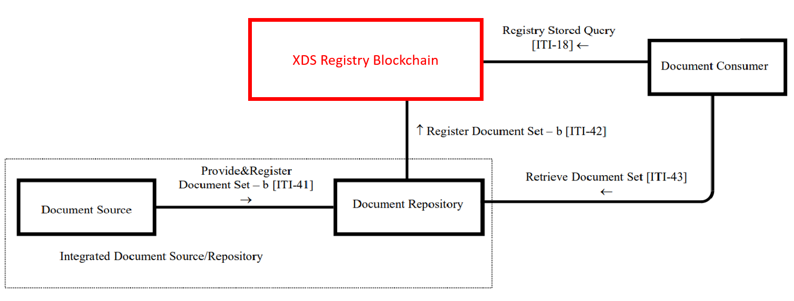

## Blockchain Components and Consensus

The main components of Blockchain comprise of the backbone engine which allows the network to form, operate, and maintain Blockchain ledger addition with consensus mechanism which maintain integrity of the network. In this work, we adopt Ethereum Blockchain platform as engine to operate components regarding cryptographical components forming ‘Block’ and ‘Chain’, Blockchain networking, actor identifying, transaction mapping, and maintaining the ledger. By ensure integrity of every ‘Block’ and ‘Chain’ identified by its hash value, this guarantees that no one can ever be able to modify anything published to Blockchain. This made all data within Blockchain to become persistent and always available to access if most of the network still exist. That means even if there are incident happened to one node, it will have no effect on the chain which is an advantage gaining from Blockchain compared to centralized database.

For consensus, it needs to be the consensus that can process large amount of Blockchain transactions at certain time due to continuous nature of medical operation and the loss of even single transaction is unaffordable. At the same time, it cannot be those mechanisms that consume excessive amount of computational resources from each node as most of participant will have limited resource to invest in Blockchain network. Combined with nature of permissioned chain which allow only selected participant to participate as node, this led the design to rely on consensus that based on majority of participant nodes are being reliable. i.e. PBFT. This kind of consensus require at least 2/3 of participant node to approve authenticity of transactions block being publish into the chain. The mechanism took the key role which guarantees that no one will be able to attempt modifying any publishing transaction before it entered the chain. The concept passively ensures that every data published in the chain was not differed from the original version introduced to the network by its owner. With these main components of Blockchain combined, it guarantees integrity of data from the moment it was introduced to the network until it successfully published into the chain as transaction and remain there as it became persistent and immutable in the network. All these mechanisms gave transparency in process of publishing data and keep it in the Blockchain, generate ‘trust by design’ for the network.

## Establish foundation of trust amongst the network

Foundation of ‘trust’ was formed from its core components in Blockchain. However, as strength of Blockchain rely on number of participants being reliable node, there still need a method to recruit new participants into the network. Blockchain participant nodes must be verified by member of the network before allowed to participate and interact with Blockchain. This can be done by establishing agreement or policy that requires the applicant to comply. It will vary depend on business model and common of interest amongst potential participant of the network. With an aid of ‘trust by design’, there are less factors to consider for joining the network in technical term. In this work, we assume that common of interest of the network is to be able to share their health document with each other using XDS.b Profile while ensure that the central registry created by the profile cannot be compromised by any kind of incident as if majority of the network was not affected. Then this allows the network to have health document sharing available even some amount of its members became victim to cyber incidents.

## Integrating Blockchain with XDS.b

In IHE ITI Technical Framework, they specified that XDS Document Registry actor who act as hub that registered all essential information about all health documents generated and kept by XDS Affinity Domain, should be a database that allows Document User to query for information of health Document they seek. The existing solution for the database is utilization of SQL or non-SQL centralized database. In this work, we propose replacing of these centralized databases with Blockchain ledger as shown in Figure 3. According to Figure 1, our Blockchain design will take the role of Document Registry. That means each Blockchain node will keep, operate, and maintain copy of Blockchain ledger that contains entire health document registry entry. Following guideline provided by IHE ITI Technical Framework, all node will receive ITI-42 transaction from its local Document Repository. The node then interprets the transaction and convert it into Blockchain transaction before broadcasting it to all nodes in the network via Blockchain protocol. At the same time, every node will interpret ITI-18 transaction from Document Consumer and query for information of health document via Smartcontract. For current work, we assume that ITI-61 transaction will be further implement to the Blockchain concept in the future. Additionally, we assume that patient identification was standardized amongst all the network beforehand, so it eliminates the need of ITI-44 transaction in our implementation. In summary, data content that going to be published into Blockchain is META-data attributes of available health document which specified information essential for health information sharing software complied with IHE XDS.b Profile to discover and retrieve document in other enterprise.

Compare to original Cross-Enterprise Document Sharing Framework (XDS Framework), we replaced traditional database for XDS Registry Actor with blockchain ledger. With blockchain applied, this new XDS Registry now gained blockchain characteristics. Immutability keep XDS Registry persist as the network still exist. All members within XDS Affinity Domain always have up-to-date version of XDS Registry as distributed characteristics of blockchain force every member to maintain the same copy of ledger at all time. With decentralization and consensus mechanism deployed, the blockchain network now gain transparency in Block addition process and can be guaranteed that no one have absolute right to manipulate transaction in blockchain at their own will. This given the foundation of “trust” which allows different healthcare enterprises to share their documents with each other even they are not fully trust one another. Additionally, to allow compatibility of new XDS Registry to be able to operate with existing XDS transaction of XDS Framework, we also implemented XDS transactions interpreter to act as the middle between original framework and blockchain. This allow our new XDS registry blockchain to work almost seamlessly with existing system currently complied to XDS Framework.

## XDS Blockchain and Smartcontract Design

As shown in Figure 4, Smartcontract will be the main component that takes the role to keep all set of META-data attributes containing information of existing health document in the network Each set of information differentiated by characteristics of its original document, within Blockchain ledger. When Document Registry Searcher program was triggered by ITI-18 transaction, it will perform iteration search on all META-data attributes set existing on the chain. All matched set will return as query result to Document Consumer as a list for its user to pick the one they needed. After the user picked the set they needed, user-side program within Document Consumer will trigger Smartcontract to return the whole set of META-data attributes of the selected set. Eventually, user-side program will use information provided by retrieved META-data attributes to access actual document in its repository in document owner hospital.

Figure 4 Overview of the design to integrating Blockchain with XDS.b Framework

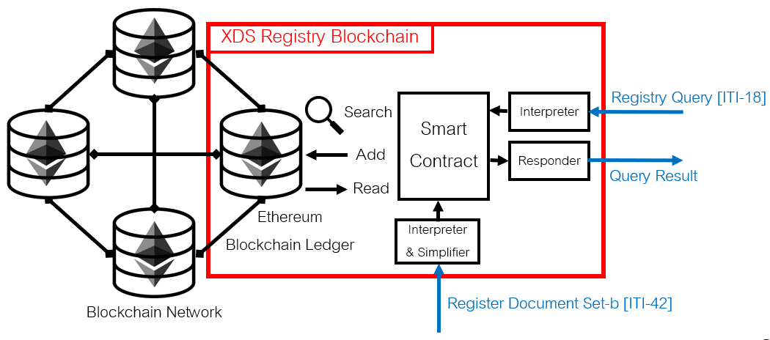

## An augmentation to mitigate data-corruption incident

In original XDS Framework, the sole purpose of the framework is to allow health document sharing between different enterprises. In this work we also propose utilization of Blockchain technology to further help in mitigation against data-corruption incident like ransomware or wipe-ware. This can be done by requiring those members node to use their XDS Repository to act partially as data-backup for one another in the blockchain network. After certain node have retrieved copy of health document from another node using information provided in XDS Registry. XDS Repository of the node simply need to update additional access pathway for the copy into the registry of the original document within XDS Registry (shown in Figure 5) as to provide alternative pathway to access the document. By doing so, even the original repository affected by data-corruption incident and lost data of the original document, there still have alternative pathway to access copy of the document available. Consider healthcare operation which requires huge amount of health information sharing by nature, a lot of available alternative pathway for health document can be expected in actual deployment. This concept will help member of the network in better mitigation against raising cyber-incident that cause data-corruption. The more they share their information with other, the more alternative copy of certain health document become available. This concept further motivates the network to maintain XDS Blockchain and share their health document with one another, empowering healthcare industry and its cyber-security performance.

A

XDS  
Blockchain

B

Timeline

Update alternative access pathway

Request Mr.Bob’s document via contact info. provided by META in registry.

Return Mr.Bob document

Figure 5 Augmentation from original framework

# IMPLEMENTATION

This section explains about our implementation to demonstrate the proposing concept.

## XDS.b Profile review, requirement gathering, and transaction analysis

In IHE ITI Technical Framework specified that … There is XDS Toolkit was provided by United States National Institute of Standards and Technology (NIST) [40]. The toolkit was developed to allow developers to test their software if it complies with IHE XDS.b profile and can communicate with other system. In this work we use the toolkit to generate sample transactions to test with our transaction interpreter program and verify that XDS Blockchain node can work with common XDS.b complied system.

## Blockchain Network Setup

To directly command behavior of each Blockchain node, we require Geth client which allows user to issue command to the node like start-stop mining and start sync Blockchain data with other node. For programming smart contract, Ethereum providing IDE for Solidity language that can compile and deploy smart contract to local Ethereum node. To interface our program to Ethereum smart contract, we can use Ethereum API tools like Web3js [38] as a middle. Web3js allows smart contract control through Javascript language and transition variable from Javascript to Solidity. Then, Blockchain platform is ready for smart contract design and implementation of XDS.b profile.

## Implementing XDS Document Registry Actor

In the implementation of this work, XDS Document Registry actor will be the main actor that will be converted from using common database to use Blockchain ledger to keep associated data. The software program must be able to communicate with XDS Document Repository actor and XDS Document Consumer actor. At the same time, the software will need to act as the middle between XDS system and Blockchain. Then, Blockchain platform is ready for smart contract design and implementation of XDS.b profile.

## Implementing Document Registry Smart Contract

Smartcontract was developed to store programming logic or algorithm as blockchain transaction. These smartcontract transactions can be compiled by Ethereum client which will give the result of its script or code (i.e. read or return specific value). So, we design smart contract which when executed, it will spawn smart contract that stores given document META-data attributes value within number labeled smartcontract instances which encoded in Blockchain transaction. When these instances were called, it will return the stored metadata attributes value back. Allow the search program to identify the set. At the same time, this allows document registry to store within Ethereum Blockchain. These composed to function as Document Registry Smart Contract.

# Conclusion

# discussion

This work proposed the idea about implementing IHE XDS.b profile based on Blockchain technology in the goal to allow health document sharing between enterprises while reduce the friction that prevents the scenario to make it to reality by addressing “trust” issue with Blockchain. And with Blockchain implemented, it also helps increase sustainability of health information network against cyber-attacks. For example, in the case that some hospital may be hit by ransomware and lose access to health documents, this proposed Blockchain concept may assist in retrieving lost documents from other network members who shared the documents.

# References

[1] B. Meskó, Z. Drobni, É. Bényei, B. Gergely, and Z. Győrffy, “Digital health is a cultural transformation of traditional healthcare,” *mHealth*, vol. 3, pp. 38–38, 2017, doi: 10.21037/mhealth.2017.08.07.

[2] Practice Fusion, “Benefits of Switching to an Electronic Health Record (EHR).” https://www.practicefusion.com/health-informatics-practical-guide-page-1/ (accessed Sep. 22, 2018).

[3] G. Bullhound, *Digital healthcare*, no. November. 2015.

[4] A. Marcelo, D. Medeiros, K. Ramesh, S. Roth, and P. Wyatt, “Transforming Health Systems Through Good Digital Health Governance,” *adb Sustain. Dev. Work. Pap. Ser.*, no. 51, pp. 1–15, 2018.

[5] Cisco, “The Digitization of the Healthcare Industry: Using Technology to Transform Care,” *Cisco*, vol. 1, p. 12, 2017, doi: 10.1057/978-1-349-95173-4.

[6] AIMS EDUCATION, “The Impact of Technology on Healthcare.” https://www.aimseducation.edu/blog/the-impact-of-technology-on-healthcare/ (accessed Sep. 22, 2018).

[7] T. Shaw, M. Hines, and C. Kielly, *Impact of Digital Health on the Safety and Quality of Health Care*, vol. 5, no. January. 2000.

[8] B. Weinelt, “Digital Transformation of Industries. Logistics Industry,” no. January, 2016, [Online]. Available: http://reports.weforum.org/digital-transformation/wp-content/blogs.dir/94/mp/files/pages/files/digital-enterprise-narrative-final-january-2016.pdf.

[9] “FHIR v4.0.1.” https://www.hl7.org/fhir/ (accessed Oct. 13, 2020).

[10] W. E. Hammond and J. J. Cimino, *Standards in Medical Informatics*, no. December. 2001.

[11] The Royal College of Radiologists Board of the Faculty of Clinical Radiology, “DICOM and HL7 standards.”

[12] Healthcare IT News, “The biggest healthcare data breaches of 2018 (so far).” https://www.healthcareitnews.com/projects/biggest-healthcare-data-breaches-2018-so-far (accessed Apr. 27, 2019).

[13] HIPAA Journal, “Largest Healthcare Data Breaches of 2018.” https://www.hipaajournal.com/largest-healthcare-data-breaches-of-2018/ (accessed Apr. 27, 2019).

[14] Healthcare IT News, “The biggest healthcare breaches of 2017.” https://www.healthcareitnews.com/slideshow/biggest-healthcare-breaches-2017-so-far?page=1 (accessed Sep. 11, 2018).

[15] A. Le Bris and W. El Asri, “STATE OF CYBERSECURITY &amp; CYBER THREATS IN HEALTHCARE ORGANIZATIONS Applied Cybersecurity Strategy for Managers,” *ESSEC Bus. Sch.*, p. 13, 2017, [Online]. Available: http://blogs.harvard.edu/cybersecurity/files/2017/01/risks-and-threats-healthcare-strategic-report.pdf.

[16] D. Cosset, “The 4 characteristics of a blockchain - DEV Community.” https://dev.to/damcosset/the-4-characteristics-of-a-blockchain-2c55 (accessed Oct. 29, 2018).

[17] Deloitte, “Key Characteristics of the Blockchain,” Accessed: Oct. 29, 2018. [Online]. Available: https://www2.deloitte.com/content/dam/Deloitte/in/Documents/industries/in-convergence-blockchain-key-characteristics-noexp.pdf.

[18] Data Flair, “6 Major Features Of Blockchain | Why Blockchain is Popular?” https://data-flair.training/blogs/features-of-blockchain/ (accessed Oct. 29, 2018).

[19] Techracer-Medium, “4 Key Features of Blockchain – Techracers – Medium.” https://medium.com/techracers/4-key-features-of-blockchain-5a4aff025d38 (accessed Oct. 29, 2018).

[20] D. Yaga, P. Mell, N. Roby, and K. Scarfone, “Blockchain Technology Overview (NISTIR-8202),” *Draft NISTIR*, p. 59, 2018, doi: 10.6028/NIST.IR.8202.

[21] henriquegaia, “ethereumbook/07smart-contracts-solidity.asciidoc at develop · ethereumbook/ethereumbook · GitHub.” https://github.com/ethereumbook/ethereumbook/blob/develop/07smart-contracts-solidity.asciidoc#what-is-a-smart-contract (accessed Aug. 23, 2020).

[22] V. Buterin, “A NEXT GENERATION SMART CONTRACT & DECENTRALIZED APPLICATION PLATFORM.”

[23] K. Peterson, R. Deeduvanu, P. Kanjamala, and K. Boles, “A Blockchain-Based Approach to Health Information Exchange Networks,” *Mayo Clin.*, no. 1, p. 10, 2016, doi: 10.1016/j.procs.2015.08.363.

[24] A. Ekblaw, A. Azaria, J. D. Halamka, A. Lippman, I. Original, and T. Vieira, “A Case Study for Blockchain in Healthcare: " MedRec " prototype for electronic health records and medical research data,” *IEEE Technol. Soc. Mag.*, pp. 1–13, 2016, doi: 10.1109/OBD.ta b2016.11.

[25] G. Zyskind, O. Nathan, and A. S. Pentland, “Decentralizing privacy: Using Blockchain to Protect Personal Data,” *Proc. - 2015 IEEE Secur. Priv. Work. SPW 2015*, pp. 180–184, 2015, doi: 10.1109/SPW.2015.27.

[26] IHE International Inc, “About IHE.” https://www.ihe.net/about_ihe/ (accessed Sep. 11, 2018).

[27] IHE International Inc, “IHE IT Infrastructure ( ITI ) Technical Framework Volume 1 Integration Profiles,” *Int. J. Healthc. Technol. Manag.*, vol. 1, no. 8.0, pp. 1–177, 2008, doi: 10.1504/IJHTM.2008.017371.

[28] “Blockchain Consensus: A Simple Explanation Anyone Can Understand.” https://blockgeeks.com/guides/blockchain-consensus/ (accessed Oct. 13, 2020).

[29] D. Mingxiao, M. Xiaofeng, Z. Zhe, W. Xiangwei, and C. Qijun, “A review on consensus algorithm of blockchain,” *2017 IEEE Int. Conf. Syst. Man, Cybern. SMC 2017*, vol. 2017-Janua, pp. 2567–2572, 2017, doi: 10.1109/SMC.2017.8123011.

[30] “Proof-of-Work, Explained.” https://cointelegraph.com/explained/proof-of-work-explained (accessed Oct. 13, 2020).

[31] S. De Angelis, L. Aniello, R. Baldoni, F. Lombardi, A. Margheri, and V. Sassone, “PBFT vs proof-of-authority: Applying the CAP theorem to permissioned blockchain,” *CEUR Workshop Proc.*, vol. 2058, pp. 1–11, 2018.

[32] D. Drescher, *Blockchainbasics*. Apress, Berkeley, CA.

[33] Z. Zheng, S. Xie, H. Dai, X. Chen, and H. Wang, “An Overview of Blockchain Technology: Architecture, Consensus, and Future Trends,” *Proc. - 2017 IEEE 6th Int. Congr. Big Data, BigData Congr. 2017*, no. June, pp. 557–564, 2017, doi: 10.1109/BigDataCongress.2017.85.

[34] K. Sultan, U. Ruhi, and R. Lakhani, *CONCEPTUALIZING BLOCKCHAINS: CHARACTERISTICS & APPLICATIONS*. 2018.